[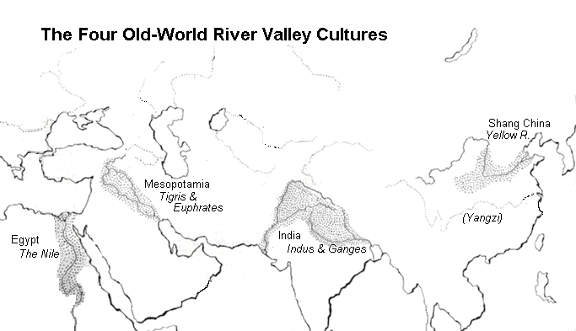](http://rds.yahoo.com/_ylt=A0PDoX5TbnZOIRIANbujzbkF;_ylu=X3oDMTBpcGszamw0BHNlYwNmcC1pbWcEc2xrA2ltZw--/SIG=12hpg6nfd/EXP=1316413139/**http:/www.unionparishschools.org/rivervalleyciv/interest.htm)

**Early River Valley Civilizations**